The bar graph given below shows the foreign exchange res

The given pie chart shows the data regarding the percentage distribution of the number of people affected by floods in five different districts in Indian state of Kerala. Total number of people affected in the given 5 districts is 24500.

Total people affected (in each district) = Males + Females

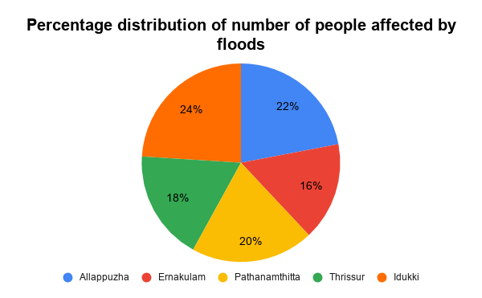

1.Find the average of number of people affected by flood in Allappuzha, Pathanmathitta, and Idukki district of Kerala.
A. 3,920
B. 4,410
C. 5,390
D. 5,880
E. None of these
If the ratio of males to females affected by flood in Ernakulam district and Pathanmathitta is same, that is 4:3 respectively, then the number of females affected by flood in Ernakulam district is what percentage more or less than the number of females affected by flood in Pathanmathitta district?
A. 20%
B. 25%
C. 40%
D. 50%
E. 80%

Find the difference between the average of number of people affected by flood in Allappuzha and Ernakulam district taken together and average of number of people affected by flood in Pathanmathitta and Idukki district taken together.
A. 575
B. 645
C. 735
D. 825
E. 965

Find the ratio of number of people affected by flood in Thrissur to the number of people affected by flood in Idukki district.
A. 2:3
B. 3:4
C. 4:5
D. 5:6
E. None of these

Directions:(1-5)Study the bar-graph carefully and answer the following questions:

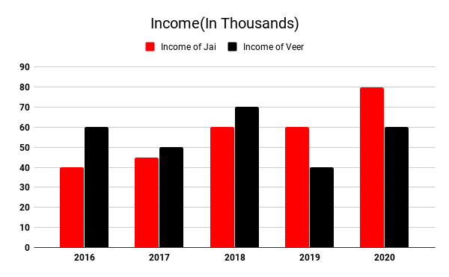
If Jai and Veer spend 30% and 45% in year 2017 then what is the total saving of Jai and Veer together in 2017?
A. 51,000
B. 53,000
C. 55,000
D. 57,000
E. 59,000

Jai’s total salary in year 2016, 2019 and 2020 is what percent more or less than Veer’s salary in same years?
A. 12.5%
B. 10%
C. 15%
D. 17.5%
E. 20%
What is the difference between the average income of Jai to the average income of Veer throughout five years.
A. 500
B. 1,500
C. 2,000
D. 1,000
E. 2,500

The given table shows the data regarding the number of medals won by different countries in Asian Games in a particular year.
Note: Total medals (won by individual country) = Gold Medal + Silver Medal + Bronze Medal
Country | Total Medals | Gold Medals | Ratio of Silver Medal to Bronze Medal
India | 56 | 12 | 6:5
Japan | 72 | 18 | 5:4
China | 118 | 31 | 2:1
Korea | 96 | 26 | 4:3
Indonesia | 80 | 15 | 8:5

Find the average of number of Bronze medals won by India, Korea and Indonesia taken together in Asian Games.
A. 18
B. 22
C. 25
D. 30
E. 32

Total number of Silver medals won by Japan and China taken together is what percentage more or less than the total number of Bronze medals won by Korea and Indonesia taken together?
A. 30%
B. 40%
C. 50%
D. 60%
E. 70%
Find the ratio of number of Silver medals won by India to the number of Bronze medals won by Japan.
A. 1:1
B. 5:4
C. 3:4
D. 3:2
E. None of these

Find the difference between the number of Silver medals won by Korea and the number of Bronze medals won by Japan.
A. 12
B. 16
C. 19
D. 23
E. 27

Jai spends its income in the ratio 5 : 3 : 2 in 2018 on investment, food, and furniture respectively. Veer spend its income in the ratio 1 : 2 : 4 in 2018 on food, furniture and investment respectively. Find the money spend on furniture by Jai and Veer together.
A. 40,000
B. 28,000
C. 32,000
D. 35,000
E. 38,000

Veer saves 25% in 2017, 35% in 2018 and 45% in 2019. Then what is the total amount spend in 2017, 2018 and 2019 by Veer?
A. 95,000
B. 1,05,000
C. 1,15,000
D. 1,25,000
E. 1,00,000
Directions:(1-5) The following table shows the revenue generated from sales of career power monthly magazine from January to June 2016, in 5 different states (PV – Printed version, OV – Online version) (The revenue given in the table is in rupees thousands)
 | Haryana |  | Delhi |  | UP |  | Gujarat |  | Rajasthan
 | PV | OV | PV | OV | PV | OV | PV | OV | PV | OV
January | 169 | 163 | 201 | 145 | 136 | 141 | 152 | 209 | 131 | 184
February | 144 | 171 | 157 | 139 | 156 | 149 | 186 | 217 | 98 | 190
March | 129 | 148 | 204 | 144 | 152 | 174 | 116 | 185 | 118 | 219
April | 163 | 139 | 232 | 139 | 168 | 207 | 129 | 156 | 174 | 236
May | 113 | 152 | 128 | 151 | 196 | 209 | 187 | 139 | 168 | 111
June | 172 | 141 | 142 | 163 | 178 | 243 | 154 | 144 | 151 | 194

What is the ratio between the revenue generated from the printed version of magazine in Haryana in all the months to the revenue generated from online version of magazine in the same state in all months together ?
A. 435 : 458
B. 458 : 435
C. 482 : 481
D. 435 : 457
E. None of these

In Delhi state, which month revenue from the online version of magazine is highest as compared to the total revenue from online version and printed version of magazine together?
A. March
B. April
C. May
D. June
E. None of these

Find the average total revenue (revenue from printed version + revenue from online version) from Rajasthan, over the months.
A. 3,96,800
B. 3,96,600
C. 3,96,500
D. 3,29,000
E. None of these

Directions(1 – 5): Study the following table carefully and answer the questions given below.
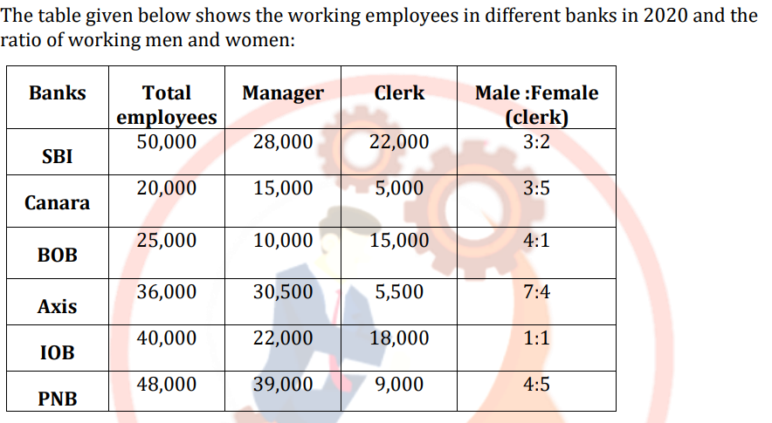
What is the difference between the total number of female working in PNB as clerk and the total number of male working in BOB as clerk?
A) 5,000 B) 6,000 C) 7,000 D) 8,000 E) 9,000

- What is the average of the number of managers in SBI, Axis and IOB?(Approximately)
1) 26733 2) 25434 3) 25334 4) 24901 5) 26833

What is the ratio of the male clerk together in PNB and Axis Bank to the male clerk together in SBI and Canara?
A) 5 : 13 B) 4 : 11 C) 13 : 5 D) 100 : 201 E) 201 : 100

The number of employees in SBI was increased by 25% from the previous year and in 2019 the number of female employees is 3700 less than the number of male employees. Find the number of female employees in SBI in 2019?
- 22,500 B) 21,850 C) 18,150 D) 16, 750 E) 15,500

Direction (Question 1 to 9): The following pie-chart shows the percentage distribution of the expenditure incurred in published a book. Study the pie-chart and answer the question based on it.
VARIOUS EXPENDITURES (IN PERCENTAGE) INCURRED IN PUBLISHING A BOOK

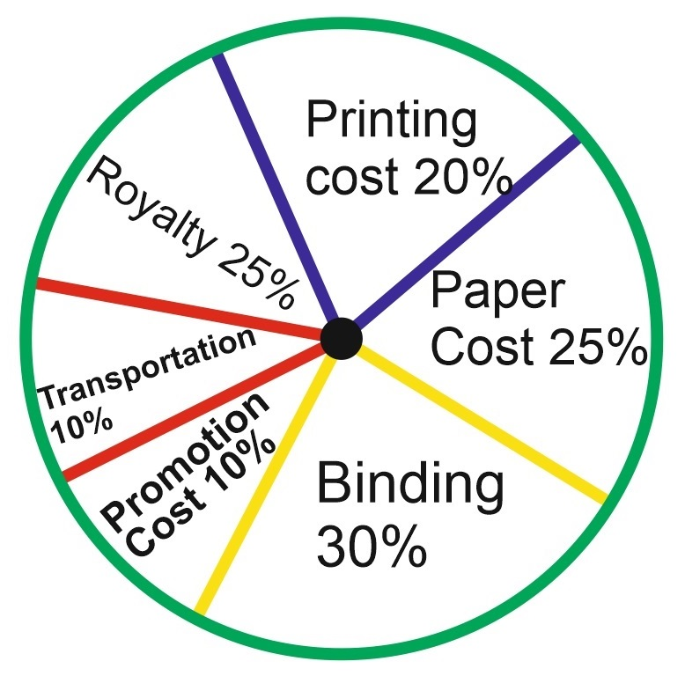
What is the central angle of the sector corresponding to the expenditure incurred on Royalty?
(A) 150
(B) 240
(C) 540
(D) 480

Which two expenditures together have a central angle of 1080?
(A) Binding Cost and Transportation Cost
(B) Printing Cost and Paper Cost
(C) Royalty and Promotion Cost
(D) Binding Cost and Paper Cost

If for an edition of the book, the cost of paper is Rs. 56250, then find the promotion cost for this edition?
(A) Rs. 20,000
(B) Rs. 22,500
(C) Rs. 25,500
(D) Rs. 28,125

If for a certain quantity of books, the publisher has to pay Rs. 30,600 as printing cost, then what will be the amount of royalty to be paid for these books?
(A) Rs. 19,450
(B) Rs. 21,200
(C) Rs. 22,950
(D) Rs. 26,150
Direction (Question 15 to 19): Study the following bar-graph and answer the question given below
Production of Fertilizers by a company (in 10000 tonnes) over the Years.
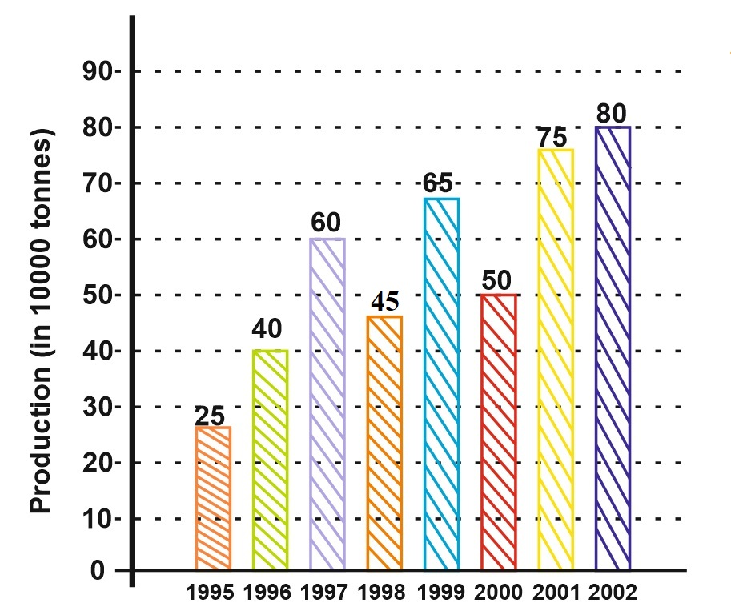
In how many of the given years was the production of fertilizers more than the average production of the given years?
(A) 1
(B) 2
(C) 3
(D) 4
(E) 5
What is the percentage increase from 1998 to 2000?

- 9.09%
(B)11.11%
(C)12.08%
(B)10%

What is the ration between the years 1995 and 1997 together to the 2001 and 2002 together
- 19:33
- 17:35
- 20:33
- 18:31

Directions (Question 20 to 27): The following line-graph gives the annual percent profit earned by a company during the period 1995-2000. Study the line graph and answer the question that are based on it
Percent profit Earned by a Company Over the Years
.
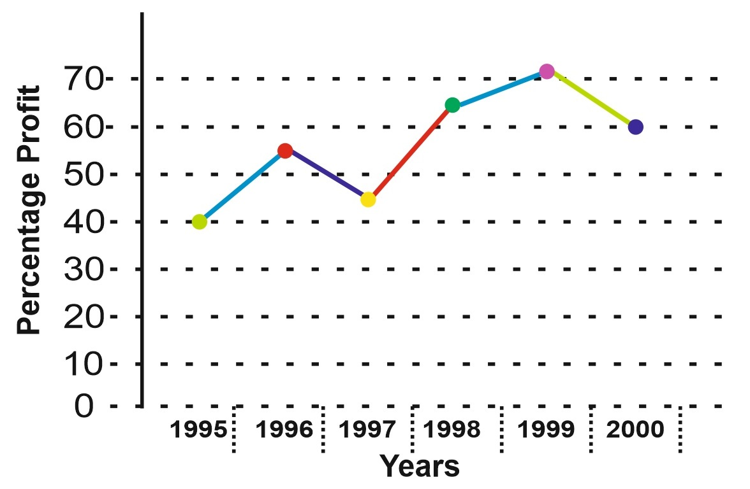
If the income in 1998 was Rs. 264 cores, what was the expenditure in 1998?
(A) Rs. 104 crores
(B) Rs. 145 crores
(C) Rs. 160 crores
(D) Rs. 185 crores
(E) None of these
During which of the following years was the ratio of income to expenditure the minimum?
(A) 1996
(B) 1997
(C) 1998
(D) 1999
(E) 2000
What is the average profit earned for the given years?
(A)
(B)
(C)
(D) 335
(E) None of these

